Theme 2: The English Bible
Book of Kells
Jonathan Jones

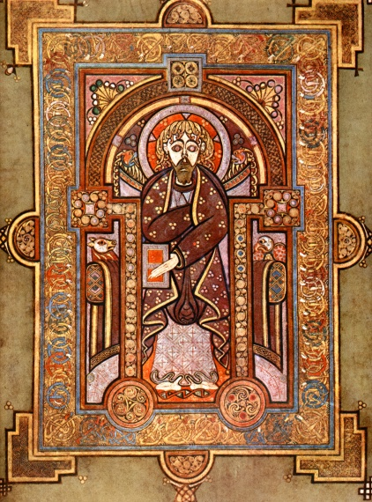
"The most precious object in the western world", as the Book of Kells was described by the Annals of Ulster about 200 years after its creation, is the work of unnamed Irish monks labouring probably on Iona, western Scotland. Nothing is certain about this enigmatic masterpiece of early medieval illumination; it could have been produced at Kells, County Meath, back in Ireland, where the Iona community founded an alternate base in 807 as a sanctuary from Viking raids.
Medieval monasteries reproduced scripture, theological writings and chronicles through manual copying and illustration. Illumination served complex purposes, from providing the illiterate laypeople with access to the book, to entertaining the copyists themselves and making interpretive connections.
The Book of Kells is universally recognised as the greatest example of medieval illumination to be produced before AD1000. The monks who made it practised the Insular style found in Ireland and Northumbria between 600 and 800, an aesthetic of decorative profusion, intertwining animals, angels, word and image.
Subject: The Book of Kells reproduces the Vulgate, St Jerome's Latin text of the gospels, together with prefatory materials: etymologies, concordances, summaries, arguments. Among these are portrait pages depicting the gospel authors, of whom two, Matthew and John, survive (Mark and Luke were either never finished or removed).
Distinguishing features: Matthew's face, with its vast, staring eyes and long, snaking yellow hair, has an ecstatic visionary aspect that transfixes. This Celtic evangelist is an enraptured, strange figure. His symmetrical features - the black arches of the eyebrows coiling into the outline of a pillar of a nose, the beard a perfectly balanced, mask-like shape - are not lacking individual features as a result of medieval clumsiness, but are emphatically cleansed of identity, transfigured into a divine, iconic generality. There is something unsettling and powerful about this face, as if transformed by knowledge into something inhuman.
In his left hand, Matthew holds a book, an object of mystery and power. Its representation folds the act of reading back on itself; the Book of Kells is a monument to the idea of the book.

Abridged from: https://www.theguardian.com/artanddesign/2003/feb/01/art
The Christmas Story in Old English:
https://www.youtube.com/watch?v=XOfvCN_F5cg

ASSIGNMENT:
Name and parallel group (A or B): ……………………………………………………
Answer the questions:

- How would you describe the origin of the Book of Kells?
- What is the origin of its name?
- What was the purpose of illumination?
- What is the content of the book?
- Describe the picture above
………..…………………………………………………………………………………………………..
……………………………………………………………………………………………………………………………………………………………………………………………………………………………………………………………………………………………………………………………………………………………………………………………………………………………………………………………………………………………………………………………………………………………………………………………………………………………………………………………………………………………………………………………………………………………………………………………………………………………………………………………………………………………………………………………………………………………………………………………………………………………………………………………………………………………………………………………………………………………………………………………………………………………………………………………………………………………………………………………………………………………………………………………………………………………………………………………………………………………………………………………………………………………………………………………………………………………………………………………………………………………………………………………………………………………………………………………………………………………………………………………………………………………………………………………………………………………………………………………………………………………………………………………………………………………………………………………………………………………………………………………………………………………………………………………………………………………………………………………………………………………………………………………………………………………………………………………………………………………………………………………………………………………………………………………………………………………………………………………………………………………………………………………………………………………………………………………………………………………………………………………………………………………………………………………………………………………………………………………………………………………………………………………………………………………………………………………………………………………………………………

- Translate:
- Kniha z Kellsu je nejvzácnějším objektem západního světa.
- Byla vytvořena Irskými mnichy.
- Středověká iluminace sloužila mnoha účelům.
- Matoušova tvář má zajímavé rysy.
- Matouš drží ve své levé ruce knihu, symbol tajemství a moci.
…………………………………………………………………………………………………………………………………………………………………………………………………………………………………………………………………………………………………………………………………………………………………………………………………………………………………………………………………………………………………………………………………………………………………………………………………………………………………………………………………………………………………………………………………………………………………………………………………………………The Formation of English Language and Timeline of English Bible History (Compare the text of John 3,16)
Adopted from http://www.greatsite.com/timeline-english-bible-history/
995: Anglo-Saxon Translations of The New Testament Produced.
“God lufode middan-eard swa, dat he seade his an-cennedan sunu, dat nan ne forweorde de on hine gely ac habbe dat ece lif."
1384: Wycliffe is the First Person to Produce a (Hand-Written) English manuscript Copy of the Complete Bible.
"for god loued so the world; that he gaf his oon bigetun sone, that eche man that bileueth in him perisch not: but haue euerlastynge liif,"
1526: William Tyndale's New Testament; The First New Testament printed in the English Language.
"For God so loveth the worlde, that he hath geven his only sonne, that none that beleve in him, shuld perisshe: but shuld have everlastinge lyfe."
1539: The "Great Bible" Printed; The First English Language Bible Authorized for Public Use
"For God so loued the worlde, that he gaue his only begotten sonne, that whosoeuer beleueth in him, shulde not perisshe, but haue euerlasting lyfe."
1560: The Geneva Bible Printed; The First English Language Bible to add Numbered Verses to Each Chapter (80 Books). Protestant Bible.
"For God so loueth the world, that he hath geuen his only begotten Sonne: that none that beleue in him, should peryshe, but haue euerlasting lyfe."
1609: The Douay Old Testament is added to the Rheims New Testament (of 1582) Making the First Complete English Catholic Bible; Translated from the Latin Vulgate (80 Books).
"For so God loued the vvorld, that he gaue his only-begotten sonne: that euery one that beleeueth in him, perish not, but may haue life euerlasting"
1611: The King James Bible Printed; Originally with All 80 Books. The Apocrypha was Officially Removed in 1885 Leaving Only 66 Books.
"For God so loued the world, that he gaue his only begotten Sonne: that whosoeuer beleeueth in him, should not perish, but haue euerlasting life."
1885: The "English Revised Version" Bible; The First Major English Revision of the KJV.
1901: The "American Standard Version"; The First Major American Revision of the KJV.
1966: The “Jerusalem Bible” (JB) is the basis of the Lectionary for Mass used in Catholic worship throughout England, Wales.
1973: The "New International Version" (NIV) is Published as a "Modern and Accurate Phrase for Phrase English Translation" of the Bible.
„For God so loved the world that he gave his one and only Son, that whoever believes in him shall not perish but have eternal life.“
1985: The “New Jerusalem Bible” (NJB) is approved for use in study and personal devotion by Roman Catholics.
2002: The English Standard Version (ESV) is published as a translation to bridge the gap between the
accuracy of the NASB and the readability of the NIV.

Further study: https://bible.org/seriespage/4-why-so-many-versions

