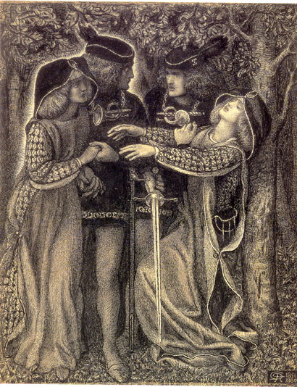 | TOWARDS FIN-DE-SIÈCLE CULTURE  (LITERATURE OF THE  LATE VICTORIAN  PERIOD)  I  SPECIAL COURSE (ENGLISH LIT.)  SUMMER SEMESTER 2024 / 2025  INSTRUCTOR: DR. ZDENĚK BERAN  TIME: TUESDAY 9:10-10:45  ROOM: P011

PROGRAMME:
1 The Aesthetic Movement (Introduction into the Period)
2 The Aesthetic Movement in Art (James Abbott McNeill Whistler et al.)
3 Formation of the New Aesthetic Thought in the 18th and 19th Centuries
4 John Ruskin and the Ideas of Beauty
5 Dante Gabriel Rossetti and the Pre-Raphaelite Brotherhood
6 Lewis Carroll and the Tradition of Nonsense (the Alice Books)
7 G. M. Hopkins and Brute Beauty (“The Windhover”)
8 Walter Pater, The Renaissance and “Emerald Uthwart”
9 Walter Pater, Marius the Epicurean
10 Vampirism in Literature (B. Stoker and others)
11 French Naturalism Visits Britain (George Moore, Esther Waters)
12 From Aestheticism to Decadence (Oscar Wilde, The Picture of Dorian Gray)
13 The Decadent Scene (Oscar Wilde, Salomé; Aubrey Beardsley et. al.)

READING LIST:
John Ruskin, extracts (handouts + “The Nature of Gothic” in the Norton Ant.)
D. G. Rossetti, “The Blessed Damozel”, “Hand and Soul”
Christina Rossetti (handout)
Lewis Carroll, Alice’s Adventures in Wonderland, Through the Looking Glass
Walter Pater, Marius the Epicurean (extracts), The Renaissance (extracts), “Emerald Uthwart”
G. M. Hopkins, “The Windhover”, “On Beauty”, extracts from other prose writings
Bram Stoker, Dracula
George Moore, Esther Waters
Oscar Wilde, The Picture of Dorian Gray, Salomé, extracts from essays

Requirements
The character of the work will very much depend on the number of students enrolled for the course. In any case, the focus will be on the reading of the assigned texts and discussions over them. The classes are planned to cover the topics and trends characteristic of the period and will combine the form of lecture and workshop, which means that I will provide some of the necessary information concerning historical and aesthetic contexts. However, it is absolutely vital that you come prepared for the class sessions: you have to read the texts in advance, make your own notes and prepare suggestions for the debate. Your active involvement will be part of the final assessment.
I will supply you with some of the texts required for the seminar reading in the form of handouts; most of them are deposited on the Moodle. Other texts, i.e. books, are available in the nearby libraries, mostly the Department library, room # 107, the Central Library of the Philosophical Faculty, and the National Library (Clementinum), or are downloadable from various Internet sources. Some handouts may be distributed during the semester some time before the class in which they will be perused.
You are expected to give one oral presentation (in the form of position paper). Apart from this, a seminar thesis is required, in the form of critical essay. The thesis topic must be decided within the first three sessions, i.e. by early March. The essay should be at least 8 pages long, the final version of the essay must be submitted to my mailbox by the end of May 2025 (at the latest). For those who need to conclude the course with an exam (i.e. a graded paper as part of their specialisation duties) an extra paper covering specific research (including at least two critical sources) will be required.
Note: Attendance in the class is mandatory.
Credits will be given on the basis of your participation, active involvement in the discussion, lucidity of oral presentations, and the quality of your critical essay.

Essay topics:
An analysis of two sonnets either by G. M. Hopkins or D. G. Rossetti, based on personal choice (3,000 words)

Graded paper topics (4,000 words):
Lewis Carroll, the Alice Books: Carroll’s Concept of Nonsense
Walter Pater, Marius the Epicurean: Analysis of the Novel
Bram Stoker, Dracula: A Symbolic Role of the Vampire
George Moore, Esther Waters: Analysis of the Novel
Oscar Wilde, The Picture of Dorian Gray: Art and Life

Presentations:
Lewis Carroll, Alice’s Adventures in Wonderland
Lewis Carroll, Through the Looking Glass
Walter Pater, Marius the Epicurean I + II
Bram Stoker, Dracula
George Moore, Esther Waters
Oscar Wilde, The Picture of Dorian Gray
Oscar Wilde, Salomé

If need be:
John Ruskin, “The Nature of Gothic”
D. G. Rossetti, “Hand and Soul”
G. M. Hopkins, “On Beauty”
Travis R. Merritt, “Taste, Opinion, and Theory in the Rise of Victorian Prose Stylism.” In: George Levine and William Madden (eds.), The Art of Victorian Prose
Alexandra Warwick, “Vampires and the Empire: Fears and Fictions of the 1890s”

Calendar for the Summer Term 2024/2025

18 February: Introduction

25 February: The Aesthetic Movement in Art (PowerPoint presentation) and Aesthetic Concepts of the 18th and 19th Centuries (overview)

3 March: John Ruskin (handouts; “The Nature of Gothic”; discussion)

11 March: D. G. Rossetti and the Pre-Raphaelites (reading texts)

18 March: Lewis Carroll and the Alice Books (oral presentation and discussion)

25 March: Gerard Manley Hopkins (reading texts, class discussion)

1 April: Walter Pater, The Renaissance (reading extracts), “Emerald Uthwart” (discussion)

8 April: Walter Pater, Marius the Epicurean (oral presentation)

15 April: Bram Stoker, Dracula (oral presentation and discussion)

22 April: George Moore, Esther Waters (oral presentation and discussion)

29 April: Oscar Wilde, The Picture of Dorian Gray: (oral presentation and discussion), extracts from essays (handout, reading)

6 May: Oscar Wilde, Salomé (oral presentation and discussion), Aubrey Beardsley’s art (discussion)

13 May: RECTOR’S DAY (class cancelled)

