CONDITIONS FOR PARTICIPATING IN PRACTICAL PATHOLOGY CLASSES in the premises of the Šikl’s Department of Pathology of the LFP UK and FN Plzeň:

- Students may not participate in practical classes if they:
  - have signs of having an infectious disease
  - are quarantined
  - have been in close contact with a COVID-19-positive person or with a person under quarantine
- The students must abide by all regulations concerning COVID-19 testing in connection with staying in a foreign country.
- Students must use an FFP2 respirator without an exhalation valve at all times during practical classes.
- Every student must bring at least 2 FFP2 respirators to practical PATHOLOGY classes (as the FFP2 respirator has to be changed after visiting the autopsy room).
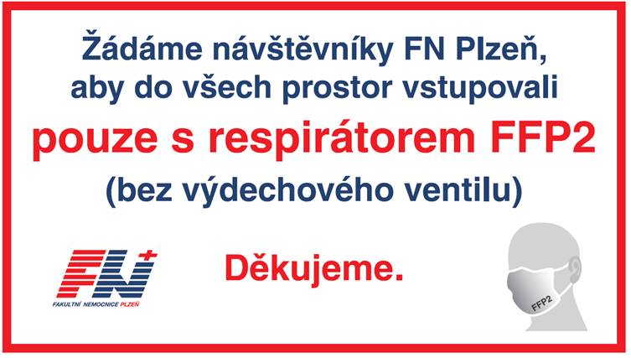
- It is not possible for FN Plzeň to provide the required personal protective equipment for students of LFP. These can be purchased at the pharmacy and/or in the medical equipment shop in FN Lochotín upon presenting a student card, or in vending machines located at gate F in FN Lochotín and pavilion 22 in FN Bory.

