**Theme 5: Parables and Interpretations x Memes**

**Name and parallel group (A or B): ………………………………………………………………………..**

1) Read the text below

2) Listen to the parables Luke 15

3) Interpret one of the images below (2, 3, 4). Find and read the respective parables in the New Testament first.

4) Think about: is there any similarity between „memes“ and „parables“ 😊?

When the books of the Bible were first written, most recipients experienced them with their ears. The apostle Paul’s letters, for example, were read aloud to the local church communities who received them.

**Listening is a way for you to experience the Bible** **and/or to know the content.**

<http://www.biblestudytools.com/audio-bible/kjv/luke/15.html>

<http://www.biblica.com/en-us/bible/online-bible/niv/luke/15/>

Cf. Interlinear text

<http://www.scripture4all.org/OnlineInterlinear/NTpdf/luk15.pdf>

Cf. further parables

<http://www.biblica.com/en-us/bible/online-bible/niv/matthew/18/>

Source: Holy Bible, New International Version®, NIV® Copyright ©1973, 1978, 1984, 2011 by Biblica, Inc.® Used by permission. All rights reserved worldwide.

1. James Tissot (French, 1836-1902), The Lost Drachma (La drachme perdue), 1886-1894 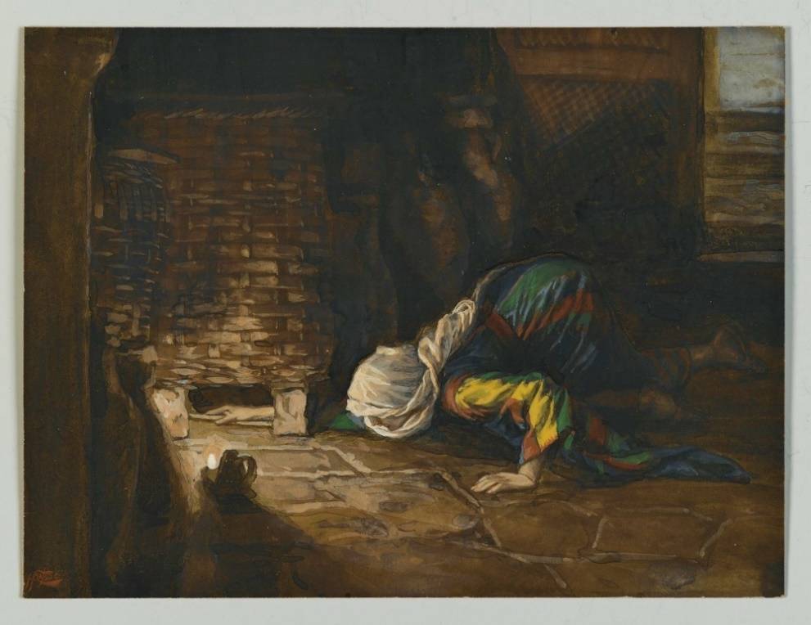

2. Paula Modersohn-Becker (German, 1876–1907), *The Good Samaritan*, 1907.



3. William Blake (England, 1757–1827), The Parable of the Wise and Foolish Virgins, 1825?

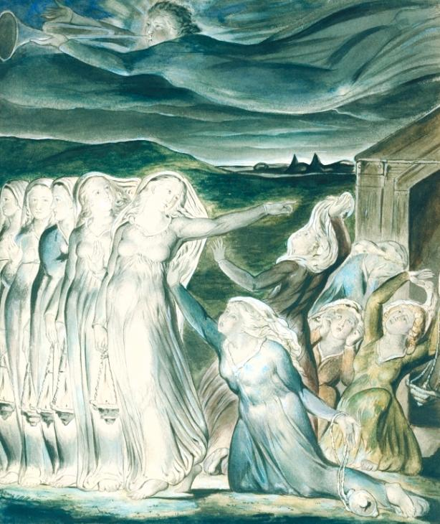

4. Rembrandt van Rijn ([Dutch Republic](https://en.wikipedia.org/wiki/Dutch_Republic" \o ") 1606-1669) - The Parable of the Rich Fool, 1627



**Parable**

-a simple story used to illustrate a moral or spiritual lesson, as told by Jesus in the Gospels.

**Synonyms**

allegory, moral story/tale, fable, exemplum

apologue, fable, allegory

*The parable he quotes, as with many of the parables from the Gospels, is symbolic in nature.*

**Introduction**

Bible scholar Madeline Boucher writes,

*The importance of the parables can hardly be overestimated. They comprise a substantial part of the recorded preaching of Jesus. The parables are generally regarded by scholars as among the sayings which we can confidently ascribe to the historical Jesus; they are, for the most part, authentic words of Jesus. Moreover, all of the great themes of Jesus' preaching are struck in the parables. (Boucher, p.9)*

**What is a Parable?**

Jesus' parables are short stories that teach a moral or spiritual lesson by analogy or similarity. They are often stories based on the agricultural life that was intimately familiar to His original first century audience. Some aspect of an unfamiliar concept, such as the kingdom of God, was compared to something from everyday life that could easily be understood.

It is the lesson of a parable that is important to us. The story is not important in itself; it may or may not be literally true.

Jesus was the master of teaching in parables. His parables often have an unexpected twist or surprise ending that catches the reader's attention. They are also cleverly designed to draw listeners into new ways of thinking, new attitudes and new ways of acting (Getty-Sullivan, pp. 2-4).

Each of Jesus' parables teaches only one or two important lessons. It is a mistake to look for meaning in every sentence or detail of the story (Lockyer, Parable). If we get bogged down analyzing the details of the parable, we may miss the central point, as in the proverbial saying, "You can't see the forest for the trees."

**Why Did Jesus Teach in Parables?**

When he was alone, those who were around him along with the twelve asked him about the parables. And he said to them, “To you has been given the secret of the kingdom of God, but for those outside, everything comes in parables; in order that

‘they may indeed look, but not perceive,

and may indeed listen, but not understand;

so that they may not turn again and be forgiven.’ ” (NRSV, Mark 4:10-12)

Jesus' explanation seems harsh and out of character. Was He deliberately trying to hide the truth by speaking in parables? Were the mysteries of the kingdom of God to be known only by the disciples? Both experts and lay persons are puzzled, and many different explanations have been proposed.

Jesus quoted from Isaiah 6:9-10. The prophet Isaiah had found that people were so lost in sin that they resented hearing God's Word and deliberately turned away. Jesus experienced the same disappointment and frustration. Thus, the most common interpretation of Jesus' saying is that the people's hardness of heart (pride, arrogance and prejudice) prevented them from understanding and accepting Jesus' teachings. Barclay explains it this way:

When Isaiah spoke he spoke half in irony and half in despair and altogether in love. He was thinking, "God sent me to bring his truth to this people; and for all the good I am doing I might as well have been sent to shut their minds to it. I might as well be speaking to a brick wall. You would think that God had shut their minds to it."

So Jesus spoke his parables; he meant them to flash into men's minds and to illuminate the truth of God. But in so many eyes he saw a dull incomprehension. He saw so many people blinded by prejudice, deafened by wishful thinking, too lazy to think. He turned to his disciples and he said to them: "Do you remember what Isaiah once said? He said that when he came with God's message to God's people Israel in his day they were so dully un-understanding that you would have thought that God had shut instead of opening their minds; I feel like that to-day." When Jesus said this, he did not say it in anger, or irritation, or bitterness, or exasperation. He said it with the wistful longing of frustrated love, the poignant sorrow of a man who had a tremendous gift to give which people were too blind to take.

If we read this, hearing not a tone of bitter exasperation, but a tone of regretful love, it will sound quite different. It will tell us not of a God who deliberately blinded men and hid his truth, but of men who were so dully uncomprehending that it seemed no use even for God to try to penetrate the iron curtain of their lazy incomprehension. God save us from hearing his truth like that! (Barclay, commentary on Mark 4:1-12)

**Interpretation**

By nature, a parable invites the reader or listener to supply the interpretation, and some of Jesus' parables have been interpreted in more than one way. Jesus, Himself, supplied the interpretation for some of His parables. But in other cases, it is left to us to determine the meaning and lesson.

Some of the parables are difficult to interpret, but the meaning is clear in most cases. Even Jesus' enemies often understood His parables, even though they did not accept the lesson (Matthew 21:45-46). Jesus' original audience in first century Palestine probably knew exactly what He was saying in most cases. Those of us who are far removed from that time and place need some help from historians and Bible scholars to understand the original cultural context and issues involved.

From historical knowledge and Jesus' other teachings, there is a broad consensus within the mainstream of Christian thought about the meaning of most of the parables. Those are the interpretations we give here.

**The Kingdom of God**

**God's Love, Mercy and Forgiveness**

**Christian Love**

**Persistence in Prayer**

**Self-Righteousness and Humility**

**Stewardship**

**Preparation for the Future**

Or - according to cardinal Martini:

**Parables about the beginning**

**Parables about the end**

**Parables about lost ones and found again**

**Parables about vocation**

**Parables about prayer**

Others

**God's Love, Mercy and Forgiveness**

*The Parable of the Lost Sheep*, *The Parable of the Lost Coin* and *The Parable of the Prodigal Son* all tell of God's infinite mercy and love.

**The Parable of the Lost Sheep**

“What man among you, if he has a hundred sheep and has lost one of them, does not leave the ninety-nine in the open pasture and go after the one which is lost until he finds it? When he has found it, he lays it on his shoulders, rejoicing. And when he comes home, he calls together his friends and his neighbors, saying to them, ‘Rejoice with me, for I have found my sheep which was lost!’ I tell you that in the same way, there will be more joy in heaven over one sinner who repents than over ninety-nine righteous persons who need no repentance.” (NAS, Luke 15:4-7)

Just as the sheep is lost and in danger, many among us are separated from God and lost in sin.

Just as the owner of the sheep makes every possible effort to find his lost sheep, God makes every possible effort to bring sinners to repentance and forgiveness.

Just as a person rejoices when a long-lost treasure is found, God rejoices when a lost sinner repents.

**The Parable of the Prodigal Son**

This is actually two parables combined in one - the parable of the younger son and the parable of the older son.

**The younger son:**

Jesus told them this story: “A man had two sons. The younger son told his father, ‘I want my share of your estate now before you die.’ So his father agreed to divide his wealth between his sons.  
  
“A few days later this younger son packed all his belongings and moved to a distant land, and there he wasted all his money in wild living. About the time his money ran out, a great famine swept over the land, and he began to starve. He persuaded a local farmer to hire him, and the man sent him into his fields to feed the pigs. The young man became so hungry that even the pods he was feeding the pigs looked good to him. But no one gave him anything.  
  
“When he finally came to his senses, he said to himself, ‘At home even the hired servants have food enough to spare, and here I am dying of hunger! I will go home to my father and say, “Father, I have sinned against both heaven and you, and I am no longer worthy of being called your son. Please take me on as a hired servant.” ’  
  
“So he returned home to his father. And while he was still a long way off, his father saw him coming. Filled with love and compassion, he ran to his son, embraced him, and kissed him. His son said to him, ‘Father, I have sinned against both heaven and you, and I am no longer worthy of being called your son.’  
  
“But his father said to the servants, ‘Quick! Bring the finest robe in the house and put it on him. Get a ring for his finger and sandals for his feet. And kill the calf we have been fattening. We must celebrate with a feast, for this son of mine was dead and has now returned to life. He was lost, but now he is found.’ So the party began.

**The older son:**

“Meanwhile, the older son was in the fields working. When he returned home, he heard music and dancing in the house, and he asked one of the servants what was going on. ‘Your brother is back,’ he was told, ‘and your father has killed the fattened calf. We are celebrating because of his safe return.’  
  
“The older brother was angry and wouldn’t go in. His father came out and begged him, but he replied, ‘All these years I’ve slaved for you and never once refused to do a single thing you told me to. And in all that time you never gave me even one young goat for a feast with my friends. Yet when this son of yours comes back after squandering your money on prostitutes, you celebrate by killing the fattened calf!’  
  
“His father said to him, ‘Look, dear son, you have always stayed by me, and everything I have is yours. We had to celebrate this happy day. For your brother was dead and has come back to life! He was lost, but now he is found!’ ” (NLT, Luke 15:11-32)

In this parable the younger son represents people who are lost in sin and the father represents God.

The younger son's demand to take his share of the inheritance early showed his youthful arrogance and disrespect for his father. Only the harsh reality of life away from his father's protection brought him to his senses. Just as the immature young son found by hard experience that his life of wild living led to desperation, we may find by hard experience that the lures of wealth and pleasure lead us to a life of emptiness separated from God.

But the father's love is the main topic of this parable. Just as the father loved his disrespectful son and longed for his return, God loves all sinners and waits patiently for them to repent and return to His love and protection.

Just as the father rejoiced when his son repented, God rejoices when a lost sinner repents.

Just as the father forgave his son and welcomed him back with full status in the family, God will forgive sinners and welcome them back with full status in the kingdom of God.

The older son represents people who are self-righteous and critical of others.

Unlike the disrespectful and foolish younger son, the older son had been loyal to his father his entire life. It is easy to understand why he felt angry and jealous about the attention his father lavished on the returning younger son. But he was also disrespectful to his father and resented the mercy his father extended to his brother.

Jesus may have originally directed this parable at the *Pharisees*, a self-righteous religious group that would rather see a sinner punished than saved. But we have to be aware of the "Pharisee" in ourselves when we are tempted to criticize, shun, exclude or punish people we think of as sinners. That is God's privilege alone ([Matthew 7:1-5](javascript:quote('Matthew_7_1_5')), [Romans 14:10-13](javascript:quote('Romans_14_10_13')), [1 Corinthians 4:3-5](javascript:quote('1Corinthians_4_3_5')), [James 4:11-12](javascript:quote('James_4_11_12'))).

Related verses: [Ezekiel 34:16](javascript:quote('Ezekiel_34_16')), [Matthew 18:10-14](javascript:quote('Matthew_18_10_14')), [Luke 6:32-36](javascript:quote('Luke_6_32_36')), [John 3:16](javascript:quote('John_3_16')), [Romans 5:8](javascript:quote('Romans_5_8')), [10:12](javascript:quote('Romans_10_12')), [2 Corinthians 1:3](javascript:quote('2Corinthians_1_3')), [1 John 4:8-10](javascript:quote('1John_4_8_10')).

Meditation: The parable of the father and his two sons is the longest one in the gospels. What is the main point of the story? Is it the contrast between an obedient and a disobedient son or is it between the reception given to a spendthrift son by the father and the reception given by the eldest son? Jesus contrasts the father's merciful love with the eldest son's somewhat harsh reaction to his errant brother and to the lavish party his joyful father throws for his repentant son. While the errant son had wasted his father's money, his father, nonetheless, maintained unbroken love for his son. The son, while he was away, learned a lot about himself. And he realized that his father had given him love which he had not returned. He had yet to learn about the depth of his father's love for him. His deep humiliation at finding himself obliged to feed on the husks of pigs and his reflection on all he had lost, led to his repentance and decision to declare himself guilty before his father. While he hoped for reconciliation with his father, he could not have imagined a full restoration of relationship. The father did not need to speak words of forgiveness to his son; his actions spoke more loudly and clearly! The beautiful robe, the ring, and the festive banquet symbolize the new life -- pure, worthy, and joyful -- of anyone who returns to God.

The prodigal could not return to the garden of innocence, but he was welcomed and reinstated as a son. The errant son's dramatic change from grief and guilt to forgiveness and restoration express in picture- language the resurrection from the dead, a rebirth to new life from spiritual death. The parable also contrasts mercy and its opposite -- unforgiveness. The father who had been wronged, was forgiving. But the eldest son, who had not been wronged, was unforgiving. His unforgiveness turns into contempt and pride. And his resentment leads to his isolation and estrangement from the community of forgiven sinners. In this parable Jesus gives a vivid picture of God and what God is like.

Source: http://www.scripture4all.org/OnlineInterlinear/NTpdf/luk15.pdf