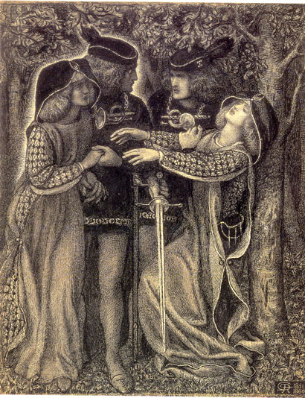 | TOWARDS FIN-DE-SIÈCLE CULTURE  (LITERATURE OF THE  LATE VICTORIAN  PERIOD)  I  SPECIAL COURSE (ENGLISH LIT.)  SUMMER SEMESTER 2022 / 2023  INSTRUCTOR: DR. ZDENĚK BERAN  TIME: TUESDAY 9:10-10:40 am  ROOM: 34

PROGRAMME:
1 The Aesthetic Movement (Introduction into the Period)
2 The Aesthetic Movement in Art (James Abbott McNeill Whistler et al.)
3 Formation of the New Aesthetic Thought in the 18th and 19th Centuries
4 John Ruskin and the Ideas of Beauty
5 Dante Gabriel Rossetti and the Pre-Raphaelite Brotherhood
6 Lewis Carroll and the Tradition of Nonsense (the Alice Books)
7 Walter Pater, The Renaissance and Marius the Epicurean
8 Walter Pater and “Emerald Uthwart”
9 G. M. Hopkins and Brute Beauty (“The Windhover”)
10 Late Victorian Literature of the Fantastic (Henry James, The Turn of the Screw)
11 Vampirism in Literature (B. Stoker and others)
12 French Naturalism Visits Britain (George Moore, Esther Waters)

READING LIST:
John Ruskin, extracts (handouts + “The Nature of Gothic” in the Norton Ant.)
D. G. Rossetti, “The Blessed Damozel”, “Hand and Soul”
A. C. Swinburne, selected poetry (+ translations from C. Baudelaire)
Lewis Carroll, Alice’s Adventures in Wonderland, Through the Looking Glass
Walter Pater, Marius the Epicurean (extracts), The Renaissance (extracts), “Emerald Uthwart”
G. M. Hopkins, “The Windhover”, “On Beauty”, extracts from other prose writings
Bram Stoker, Dracula; Eliza Lynn Linton, “The Fate of Madame Cabanel”
George Moore, Esther Waters

Requirements
The character of the work will very much depend on the number of students enrolled for the course. In any case, the focus will be on the reading of the assigned texts and discussions over them. The classes are planned to cover the topics and trends characteristic of the period and will combine the form of lecture and workshop, which means that I will provide some of the necessary information concerning historical and aesthetic contexts. However, it is absolutely vital that you come prepared for the class sessions: you have to read the texts in advance, make your own notes and prepare suggestions for the debate. Your active involvement will be part of the final assessment.
I will supply you with some of the texts required for the seminar reading in the form of handouts; most of them are deposited on the Moodle. Other texts, i.e. books, are available in the nearby libraries, mostly the Department library, room # 107, the Central Library of the Philosophical Faculty, and the National Library (Clementinum). Some handouts may be distributed during the semester some time before the class in which they will be perused.
You are expected to give one oral presentation (in the form of position paper). Apart from this, a seminar thesis is required, in the form of critical essay. The thesis topic must be decided within the first three sessions, i.e. by early March. The essay should be at least 8 pages long, the final version of the essay must be submitted into my mailbox by the end of May 2023 (at the latest). For those who need to conclude the course with an exam (i.e. a graded paper as part of their specialisation duties) an extra paper covering specific research (including at least two critical sources) will be required.
Note: Attendance in the class is mandatory.
Credits will be given on the basis of your participation, active involvement in the discussion, lucidity of oral presentations, and the quality of your critical essay.

Essay topics:
An analysis of two sonnets either by G. M. Hopkins or D. G. Rossetti (3000 words)

Graded paper topics (4000 words):
Lewis Carroll, the Alice Books: Carroll’s Concept of Nonsense
Walter Pater, Marius the Epicurean: Analysis of the Novel
Bram Stoker, Dracula: A Symbolic Role of the Vampire
George Moore, Esther Waters: Analysis of the Novel
Henry James, The Turn of the Screw: Analysis of the Novella

Presentations:
Lewis Carroll, Alice’s Adventures in Wonderland
Lewis Carroll, Through the Looking Glass
Walter Pater, Marius the Epicurean I + II
Bram Stoker, Dracula
John Ruskin, “The Nature of Gothic”
D. G. Rossetti, “Hand and Soul”
G. M. Hopkins, “On Beauty”
Travis R. Merritt, “Taste, Opinion, and Theory in the Rise of Victorian Prose Stylism.” In: George Levine and William Madden (eds.), The Art of Victorian Prose
Alexandra Warwick, “Vampires and the Empire: Fears and Fictions of the 1890s”

Calendar for the Summer Term 2022/2023

14 February: Introduction

21 February: The Aesthetic Movement in Art (PowerPoint presentation)

28 February: Aesthetic Concepts of the 18th and 19th Centuries (overview)

7 March: John Ruskin (handouts; “The Nature of Gothic”; discussion)

14 March: D. G. Rossetti and the Pre-Raphaelites (reading texts)

21 March: A. C. Swinburne (reading texts)

28 March: Lewis Carroll and the Alice Books (oral presentation and discussion)

4 April: Gerard Manley Hopkins (reading texts, class discussion)

9 – 18 April: Walter Pater, The Renaissance, Marius the Epicurean (oral presentation; reading extracts)

25 April: Walter Pater, “Emerald Uthwart” (discussion)

2 May: Bram Stoker, Dracula (oral presentation and discussion)

9 May: George Moore, Esther Waters (oral presentation and discussion)

